Proposal Response Sample

**Architecture for humanity**

[**http://architectureforhumanity.org**](http://architectureforhumanity.org)

“Architecture for Humanity is a non-profit,

that has been building a better future through the power of design for the past 15 years.

We provide architecture, planning and project management services including construction management and post-occupancy analysis, and facilitate community engagement throughout each project.

At the core of our mission, we believe **everyone deserves access to the benefits of good design.** “

[Nonprofit Name Here] is seeking submissions from a professional, highly qualified software development firm to create a fully responsive website. The website design/development will include:

* a landing page layout
  1. with featured news items and call to action for donation/purchase/ or about video
* a content page/regular page layout
* a blog/news section (with date, author, tags, comments) and a sidebar
* a place for users to login / login screen

social links (facebook, twitter, instagram) and a donate link

**Overview**

We plan to help architecture for humanity by organizing content to make it less repetitive and adding hierarchy. Divided the website into sections and tell a story in the homepage. Making a fully responsive website.

We believe that updating the branding to a sleeker, modern approach will attract a more design/architect crowd. We also want to add inviting to attract others who are looking to volunteer and donate.

**Phases/Timeline**

Description of each phase of the project, and what deliverables are included for each phase as well as dates estimations for deliverables

We will have a mood boards to determine what art direction we will take.

Every Monday we will meet to make sure we are all on the same page and ensure that things are running smoothly.

We will develop wireframes and edit content to make

**Workflow**

To develop this project we will be using github as our host, we will use jekell for structure. We will use parallax on certain sections to have some interactive sections.

**Competitive Analysis**

**Web Ideas**

* Full width banner
* Full sized images
* Better hierarchy with typography
* Use of icons
* Scrap repeating content
* Less white space
* Use of more images
* Footer arrangements
* New colours
* “About us” revamp

Doctors without borders

[www.doctorswithoutborders.org](http://www.doctorswithoutborders.org)

Public Displays of affection

[www.publicdisplaysofaffection.ca](http://www.publicdisplaysofaffection.ca)

Kounkuey

[www.kounkuey.org](http://www.kounkuey.org)

D-impact

[www.d-impact.org](http://www.d-impact.org)

Mass design group

[www.massdeisgngroup.org](http://www.massdeisgngroup.org)

Notes on all:

* Explaining what the organization does in the home page-where easily viewable
* Full size images
* Minimal Body copy on homepage
* Updates of recent events
* Obvious divided sections
* Most important info on homepage
* Obvious navigation

Mercy Corps

<http://www.mercycorps.org/>

* Donate
* Banner home page
* Stories (blog)
* Secondary footer

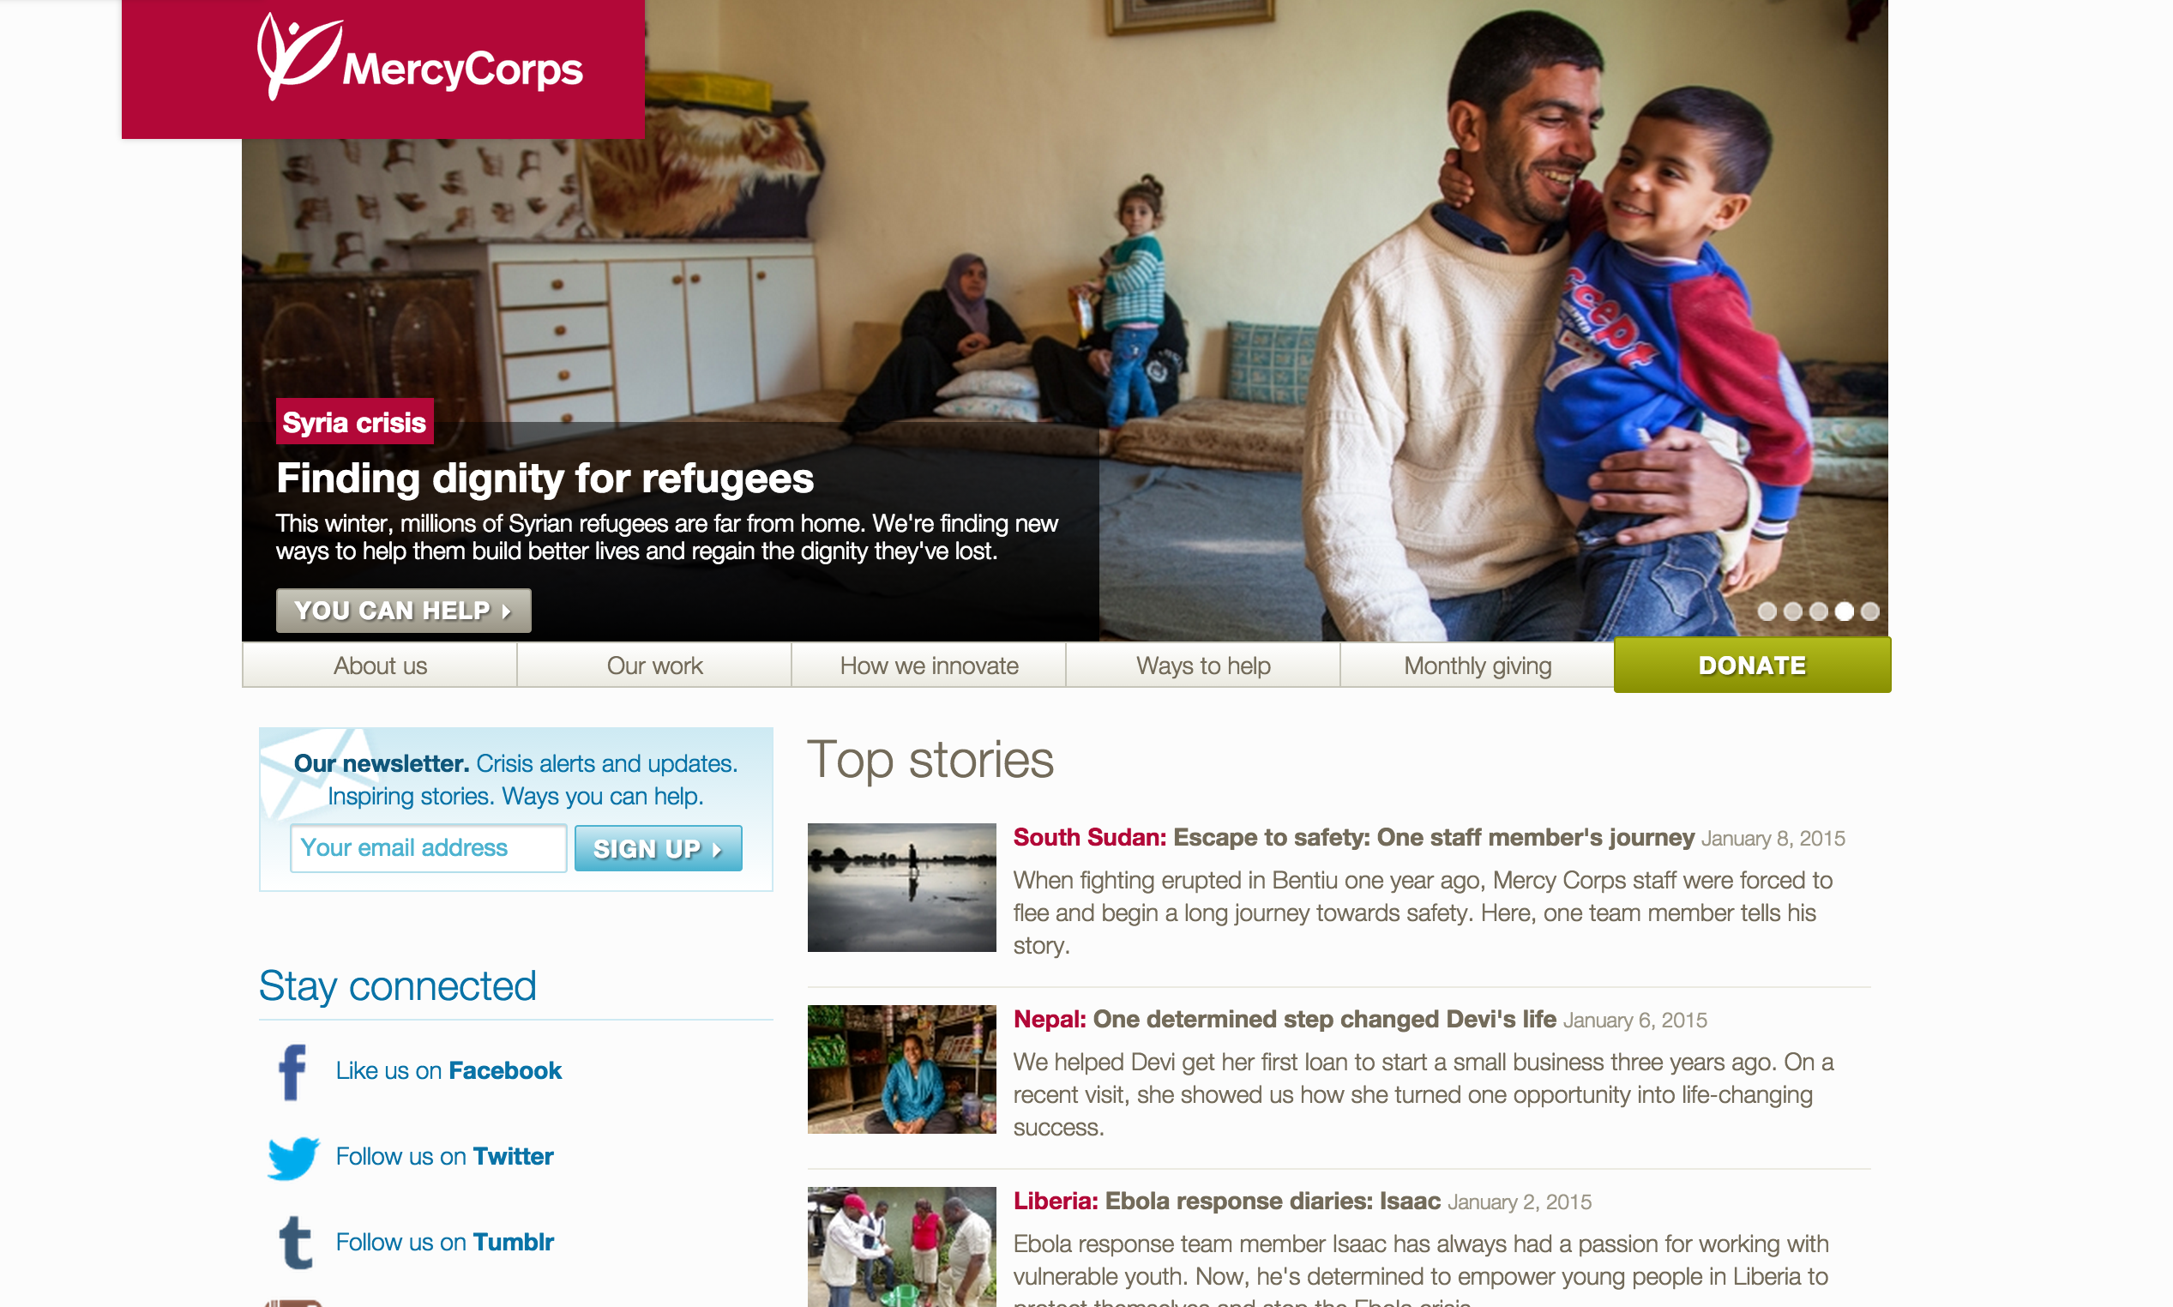

Walu International

<http://waluinternational.org/>

* Sections (hmtl syle)
* One page scroll (homepage)
* Volunter
* Press and media
* Big Footer
* donate btn

The Hunger Project

<http://thp.org/>

* Big header (pic img)
* Hover Menu
* donate btn
* one page scrollable home page
* Big text on images with btns
* News and headlines
* Fixed nav

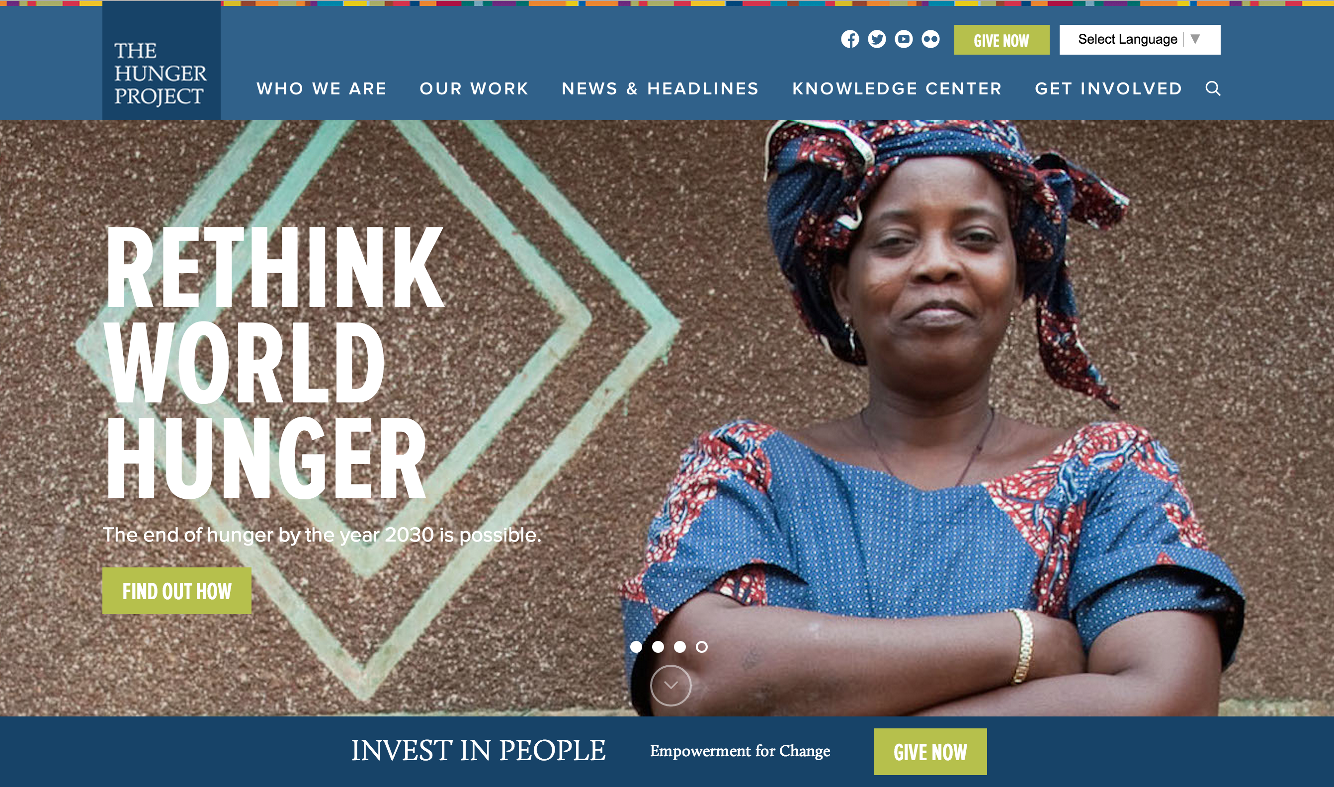

One Laptop per Child

<http://one.laptop.org/>

* Modern
* Responsive
* Good use of information
* Easy to understand

Whiz kids Workshop

<http://www.whizkidsworkshop.com/>

* Drop down hover for nav
* Responsive

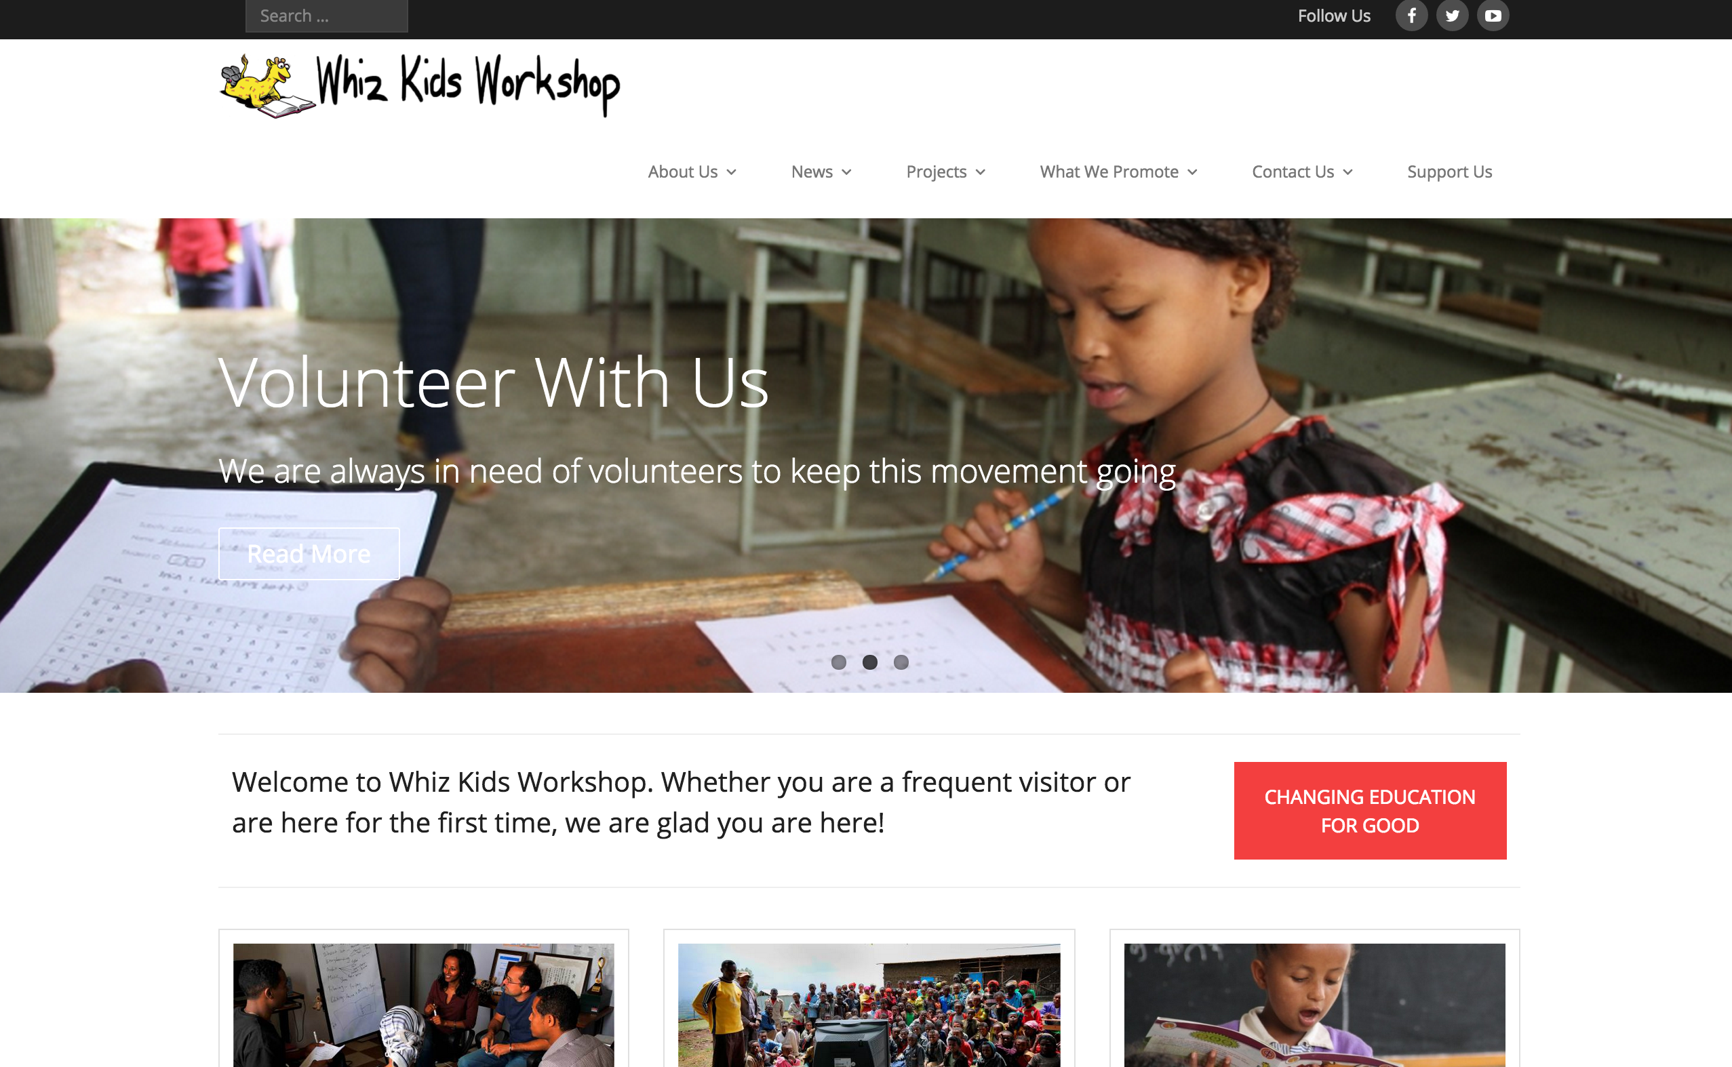

### Ideas and concept:

* Make donation aspect of the organization more evident.
* Create an online store to buy supplies that will be donated to the organization.
* Change color scheme so that website is more inviting and uplifting
* Slogan: Buy a hammer, build a school

**World Wildlife Fund**

<http://www.wwf.ca/>

* Different coloured button to put emphasis on the donating and the WWF store
* Numerous/repeating donation elements throughout website
* Lots of images showcase work

**Unicef**

<http://www.unicef.ca/>

* Picture with title and short description dividing different sections
* Donate button is number one in navigation list
* Banner image, images switches to different projects they have made
* Donating chart is third element on website

**The Snowsuit Fund**

http://snowsuitfund.com/

* Banner image focuses on the donating aspect of the organization
* Multiple tabs that lead to donating page
* Captivating images with strong tag lines
* easy step by step on how to donate

**Online Store - Home Depot**

http://www.homedepot.ca/

* Slider image banner showcasing recommended products to buy
* Side panel with list of categories for available products
* Login tab at top to keep track of purchases

**Online Store - Ikea**

<http://www.ikea.com>

* Login tab at top of website
* Banner image showcasing recommended products to buy
* Grid with images of products, categories

**Canadian Red Cross**

<http://www.redcross.ca/>

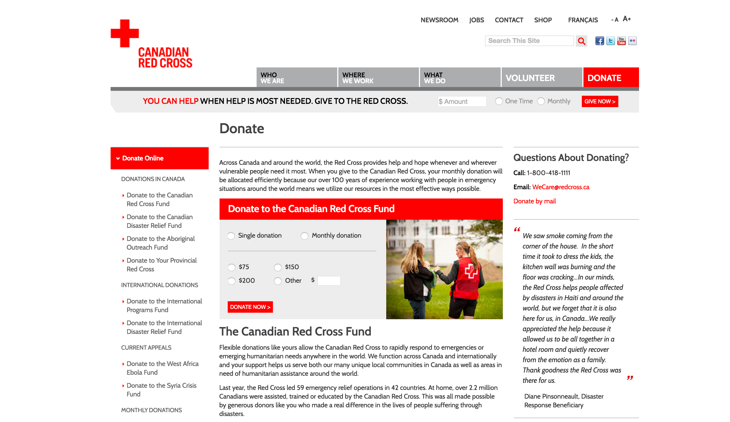

* 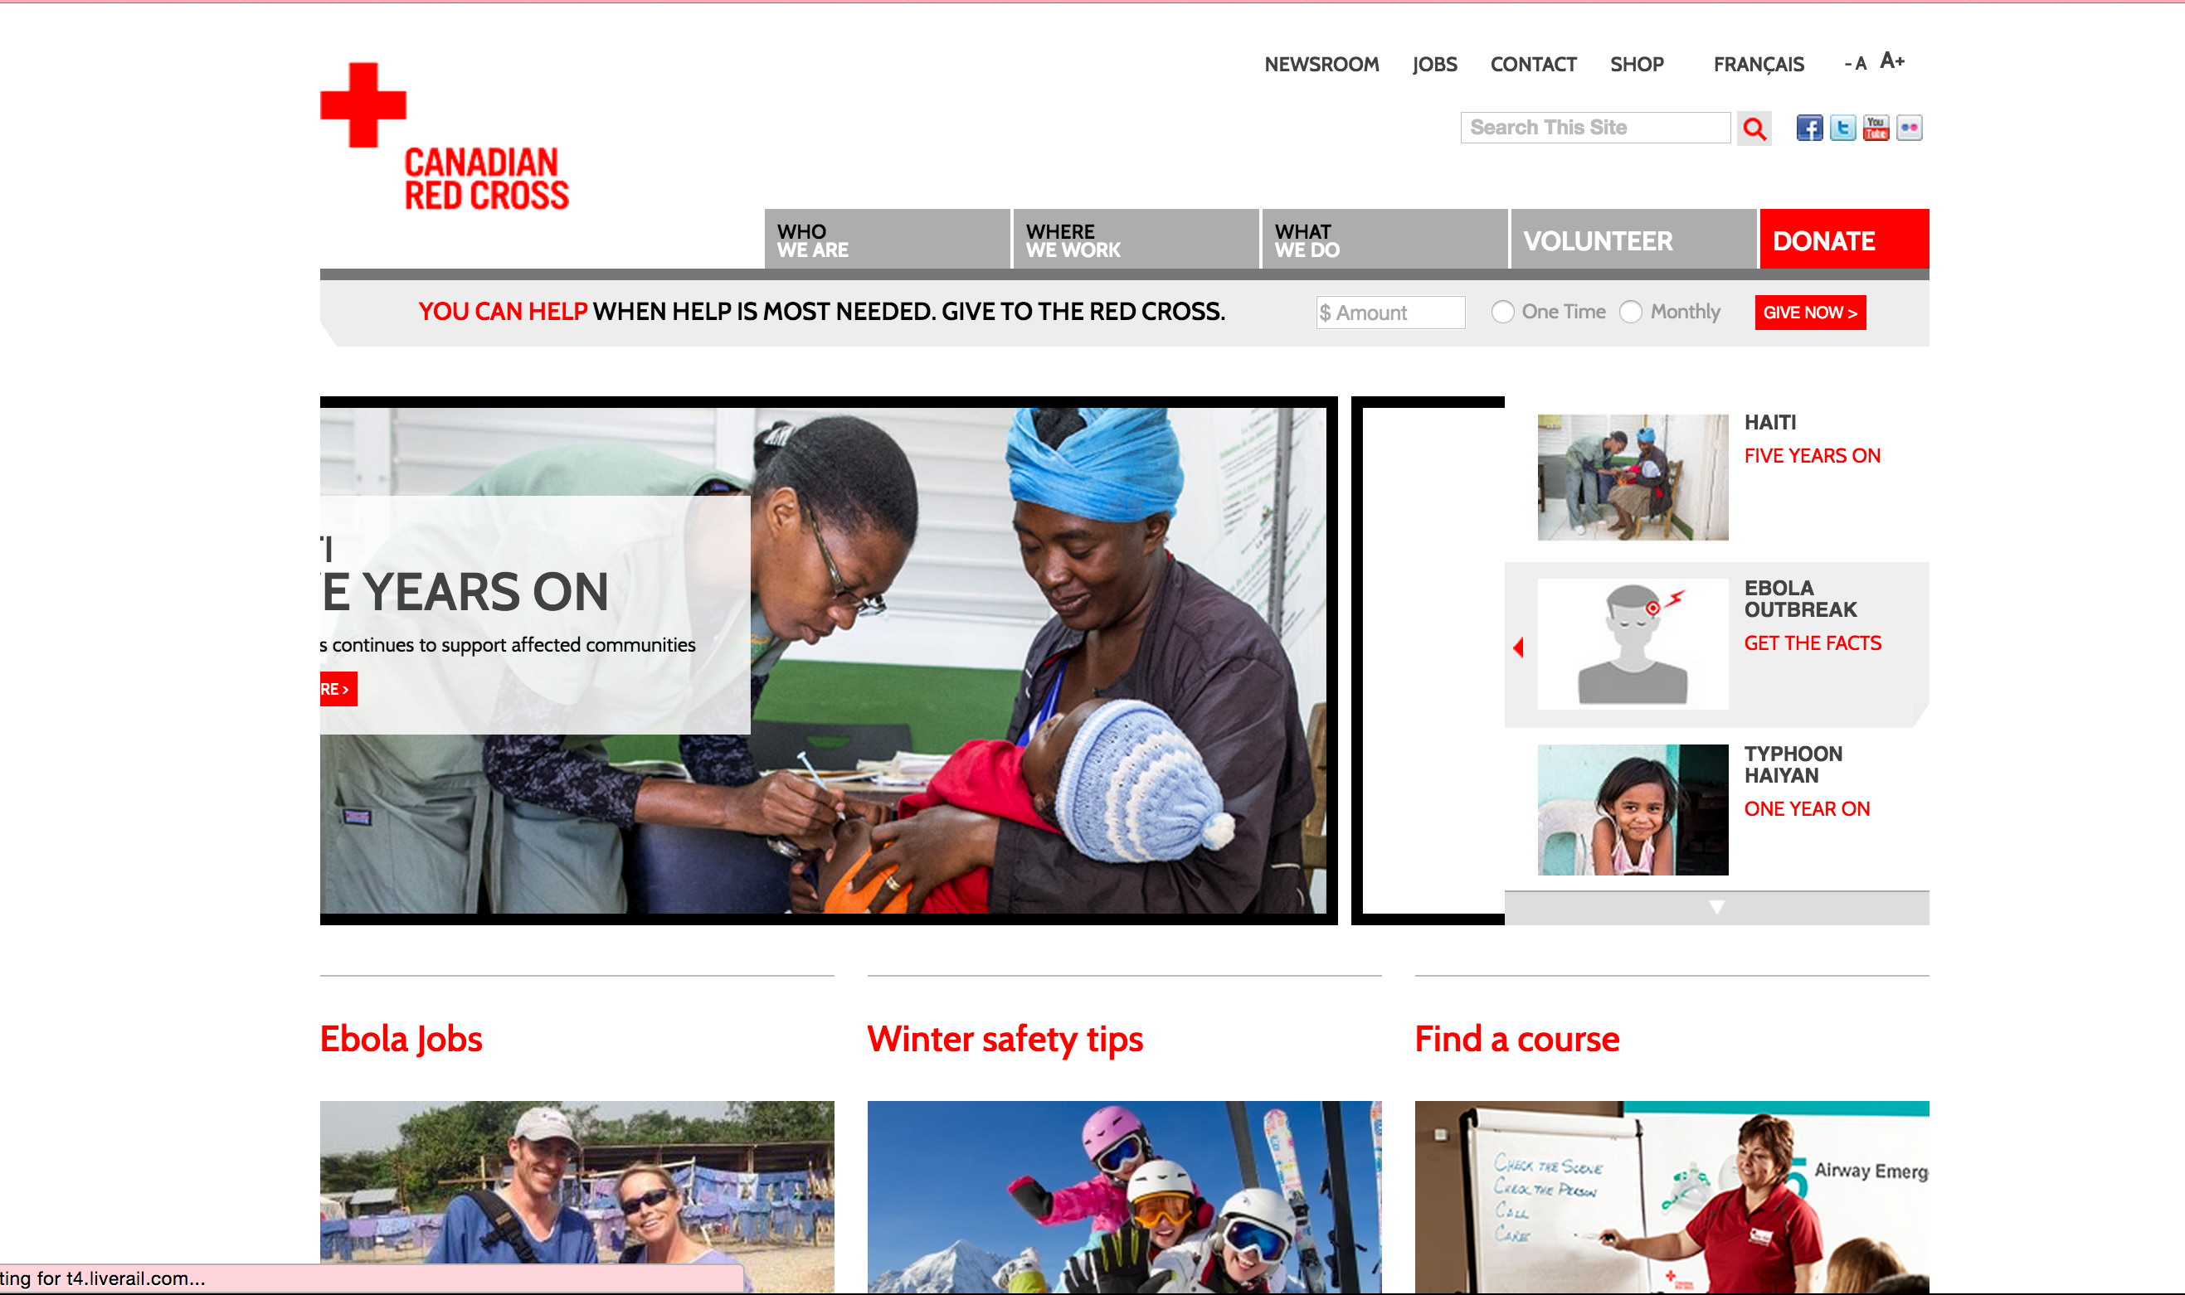Donate button is stands out amongst all other elements
* Donation box is second element on the website
* Banner image showcasing what they do
* Donation chart

**Features**

Breakdown to be implemented features of the project, what they are, with examples (for the less tech-savvy client), what cool things you plan on incorporating into your project that set you apart from other companies bidding, what may be incorporated or expanded on in the future

We want to tell a story as soon as you go on the page. This will go straight to the point and image the crowd right away. We will add parallax to make things appear subtly